

2 Minute Form
Trip Name: Sullivan’s Bay Navigation Exercises
Check-in Name and Phone:
Date: Branch:
Leaders
Cell Phone Number
VHF Call Sign &/or Vessel Name
Vehicle make, model, registration, colour
General Plan  Note: If plan changes, you must notify your Check-in person. | Sunday meet at Sullivan’s Bay at 9am for 9:30 briefing.  Navigation exercises to be held in the area generally bounded by Sullivan’s Bay, Scotts Landing, Saddle Island and Brazier Rock.  Three exercises to be undertaken:  - Triangular course. Each participant will be given bearings to paddle to. If navigated and paddled correctly these bearings will bring the participant back to the same point. The participant is to measure the ‘miss close’ when back at the start. Bearings will given to the participant in either ‘true’ or ‘magnetic’. Lesson – Can you navigate in poor visibility?  - Fixing position. Each participant will fix the position of an anchored buoy by taking bearings from their kayak. The bearings will be communicated to the Trip Leader on shore. Once back at shore the participant will then plot the result on to chart and read off the coordinates. Lesson - You need a rescue; can you let ‘Coastguard’ know where you are?  - Team geocache. Participants will be divided into teams and various navigation / rescue scenarios will be practiced. Lesson – Putting what you have practiced into practice.  The aim of the exercises is to get participants familiar with; magnetic and true north, taking bearings, plotting courses, allowing for tidal and wind drift, and paddling to compass bearings.  Participants are not to be told what equipment to bring or the exercises being undertaken. It is expected however that participants will have; compass, chart and a VHF radio / mobile phone. GPS units are not allowed.  Note: Trip Leaders will remain on shore at all times.
Latest Time Off the Water |  |  |  |  | TMP used²⁰
Tide/ Forecast Lake Level | Low |  |  | High | Other
Communications Carried²¹ | VHF radio and cell phones
Communications | We will be communicating as a group on VHF Channel 6 and 8
Equipment Carried | Normal kayaking equipment for day paddle
Trip Report
(Use other side if more space required)

Activity | Navigation Exercises | Centre | Auckland | Location |  |  |  | Sullivan’s Bay |  | Difficulty¹ |  |  |  | Beginner, but must have completed Navigation course
Activity Description | Land and water based navigation training exercises |  |  |  | Leader qualification req.² |  |  | Sea Kayak Trip Leader
Get in Location | Sullivan’s Bay |  |  |  | Chart/ Map no.⁴ |  |  | NZ 5227 |  | Distance |  |  |  | 3km to 4km maximum distance from base
Get out Location | Sullivan’s Bay |  |  |  | Coastguard Channel |  |  | 82 & 16 |  | Nowcasting |  |  |  | 21
Emergency get out ⁵ | Many locations at the mouth of the Mahurangi River |  |  |  | Emergency / Coastguard Station |  |  | Auckland |  | Phone |  | *500 / 09 303 4303
Emergency get out ⁵ |  |  |  |  | Drinking Water⁶ |  | Yes |  | Toilets⁷ |  |  |  | Yes
Emergency Response | Refer Emergency Response Booklet |  |  |  |  |  |  |  | Parking⁸ |  |  |  | Yes
Specific Equipment Required⁹ | Usual kayak safety gear. |  |  |  | Working Communications equipment in this area¹⁰ |  | Cell phone  Sat phone |  |  |  | Mountain Radio |  |  |  | PLB  VHF
Other resources  and notes¹¹ | Inform Coastguard in advance of what we will be doing as there will be a lot of radio traffic.  Course notes and scenarios, issued on the day to participants. |  |  |  | Weather Parameters¹² | Beginner: no significant surf or swell, wind under 15 knots.  Intermediate: surf or ocean swells less than 1.5 metres or wind under 25 knots.  Advanced: any condition that’s suitable for the trip’s aims.
Previous incidents¹³

Safety Management¹⁴
Hazard |  | Significant?  - E/I/M |  | Management Strategy¹⁵ |  |  |  | Hazard | Significant?  - E/I/M | Management Strategy¹⁵
Cold Water |  | Yes - M |  | Carry spare dry clothes and shelter |  |  |  | Deep Water | Yes - E | Correctly fit PFDs
Medical Conditions |  | Yes - M |  | - Leader has first aid qualification  - Ask customers about medical conditions |  |  |  | Bad Weather | Yes - M | Understand weather forecasts.  Have back up plans or pull out if necessary
Capsizing |  | Yes - M |  | - Correctly fit PFDs  - Skills at performing rescues. |  |  |  | Heat / Sun | Yes - M | - Protective Clothing (worn), Sunglasses, Hat  - Sun Screen  - Plenty of drinks
Panic |  | Yes - M |  | Ensure conditions match level  of skills |  |  |  | Obstacles | Yes - M | Awareness of reefs, navigational hazards, nets
 |  |  |  |  |  |  |  | Other Vessels | Yes - M | - Understand the “rules of the sea”  - “Be seen” – Have two of the following; flag, brightly coloured kayak, brightly coloured Pfd or hat. At night: an all- round white light & a powerful torch.
Written up by: | Diana Austin |  | Approved By: |  | Russell Williams | Signed: | RW |  | Date: | 1 August 2014 | Review in: | 12 months from date of approval

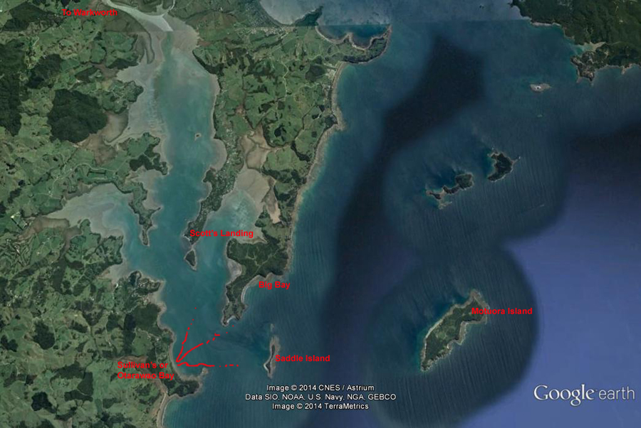

Additional Information Sheet (Optional)
Introduction (A general introduction)
Description (A description of the tour – as if you were selling the idea to someone)
Local Attractions |  | Transport/ Local Operators
 | Contact details |  | Contact details
Local Eateries
 | Contact details
Accommodation/ Campsite Locations |  |  | Facilities
Name |  |  | Cabins |  | Fuel
Phone |  |  | Showers |  | Power
E-mail |  |  | Toilets |  | Water Access
Website |  |  | Laundry |  | Pool
Physical Address |  |  | Water |  | Fires Allowed
Other |  |  | Supplies
Other information

Activity Equipment Check list
Equipment List
- Helmet (rivers & surf) Group Gear
❑ Beanie / hat  Split paddles
❑ Thermals  Repair kit
❑ Paddle Jacket  Fire lighting
❑ PFD  Cooker/thermos
❑ Spray deck  Spare thermals
❑ Booties  Tow system
❑ Water & food  1st Aid Kit
❑ Kayak & paddle  Flares
Group - Oceans & Lakes  Compass
❑ Pumps & Paddle Floats  Charts / Maps
Group - River  GPS (optional)
❑ Throw ropes  Knife (cut rope)
❑ Pin kit & saw  Emergency Shelter

In case of emergency: Dial 111, Mayday :VHF Channel 16

Kayaking Check list

❑ Trip plan
❑ Latest weather forecast
❑ Conditions match skills?
❑ Hyperthermia (hot) &
Hypothermia (cold)
❑ On & off water safety
❑ Environmental concerns
❑ Emergency Procedures include emergency get out.
❑ Working communication devices
e.g. VHF radio, mobile phones, PLB
❑ Specific safety issues for this trip
❑ Participant list
❑ Any medical conditions
❑ All participants keen to proceed?

❑ Trip Plan/ 2-minute form lodged with Ops. Manager

Appropriate wind conditions to run trips:
Novice - no significant surf or swell, wind under 15knots
Intermediate- surf or ocean swells less than 1.5 metre or wind under 25 knots.
Advanced- any condition that is suitable to the trips aims

At conclusion of trip:
Contact check in person
Group Debrief.

Check in Person Ph:
__________________ Mobile
__________________ Work
__________________ Home

Activity Document Cover Sheet

Activity:
Date of Activity:

Activity reports. Is all relevant information present:
– Approved Trip Management Plan (TMP)/ 2 minute form
– Club Trip Participant Sheet
– Weather forecast
– Activity Check List
– Trip report (May be on the 2 minute form)
– Accident / incident reports
Leaders Signature:
Date:

